MICHIGAN
DATAMASTER DMT EVIDENTIAL BREATH TESTING
TRAINING MANUAL 2018

CLASS II OPERATOR

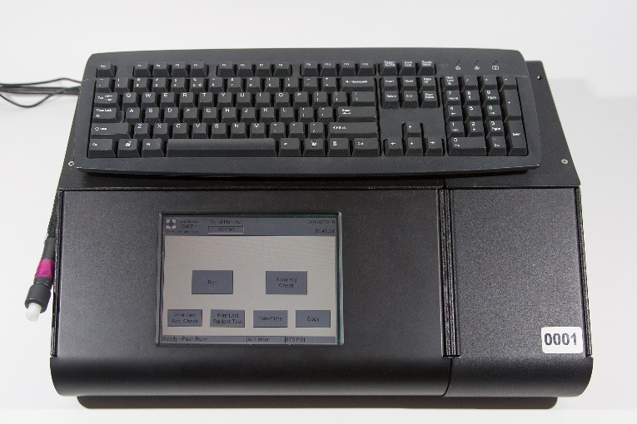

MICHIGAN STATE POLICE
TRAINING DIVISION

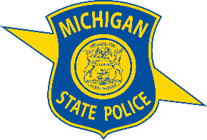

Table of Contents
Preface 7
Introduction 8
DATAMASTER DMT Functional Parts 9
DATAMASTER DMT Exterior Components 9
DATAMASTER DMT Rear Panel 10
DATAMASTER DMT PRINTER 11
Subject Test Sequence 12
Refusal/Incomplete Test 18
Refusals 19
Incomplete Test 19
Accuracy Checks 21
Manual Accuracy Check Sequence 22
Accuracy Test Print Outs 24
Display Messages 25
Invalid Sample 25
Chemical Interference 26
Radio Frequency Interference 28
Ambient Fail 29
Blank Error 29
Pump Error 30
Print failed due to error 30
Start of observation time less than 15 minutes 31
Standard Out of Range 31
Out of Service 32
Sample Chamber not to temp 32
Breath Tube not to temp 33
EVIDENCE TICKETS 34
Sample and Refusal 34
Operator Refusal 35
Invalid Sample 36
RFI Detected 37
Date/Time Modifications 38
Administrative Forms 40
OD-80 (Accuracy Check) 40
OD-80 (Subject Test) 41
OD-80 (Accuracy Test) 42
OD-80 (Subject Test) 42
OD-33 Evidential Breath Testing Log 43
OD-33 Form 45
DI-93 Officer’s Report of Refusal to Submit to Chemical Test 46
DI-93 Form 47
DI-177 Breath, Blood, Urine Test Report 48
DI-177 Form 49
Courtroom Testimony 50
Administrative Rules 54
R 325.2651 Definitions. 54
R 325.2652 Approved equipment. 55
R 325.2653 Equipment accuracy. 55
R 325.2654 Equipment repair and service. 56
R 325.2655 Techniques and procedures. 56
R 325.2656 Rescinded. 58
R 325.2657 Rescinded. 58
R 325.2658 Operator training and certification. 58

Preface

The purpose of this manual is to train law enforcement personnel in the proper use of the DATAMASTER TRANSPORTABLE (DMT) breath alcohol testing instrument.

Upon successful completion of this training program, a certified operator will be able to administer a breath alcohol test on a suspected intoxicated subject in the State of Michigan. The operator will be familiar with the operating principle of the DATAMASTER DMT; know the exterior components of the instrument; and know the pretest, subject, and accuracy check procedures and sequences.

Questions regarding the DATAMASTER DMT can be directed to the Michigan State Police at MSP-AlcoholUnit@michigan.gov

Introduction

The DATAMASTER TRANSPORTABLE (DMT) is an infrared evidential breath alcohol test instrument manufactured by National Patent Analytical Systems, Inc. The operating principle of the DATAMASTER DMT is based on infrared absorption.

Infrared technology as applied to breath alcohol analysis had its origin in the early 1980s. This advent of increasing technology prompted the development of an infrared breath alcohol analysis program in Michigan. With their ease of operation, more rapid analysis, and advances in computer technology, infrared devices have taken over the testing for breath alcohol. The DATAMASTER DMT has evolved through the years to its present state-of-the-art instrument with expanding computer capabilities.

The DATAMASTER DMT:

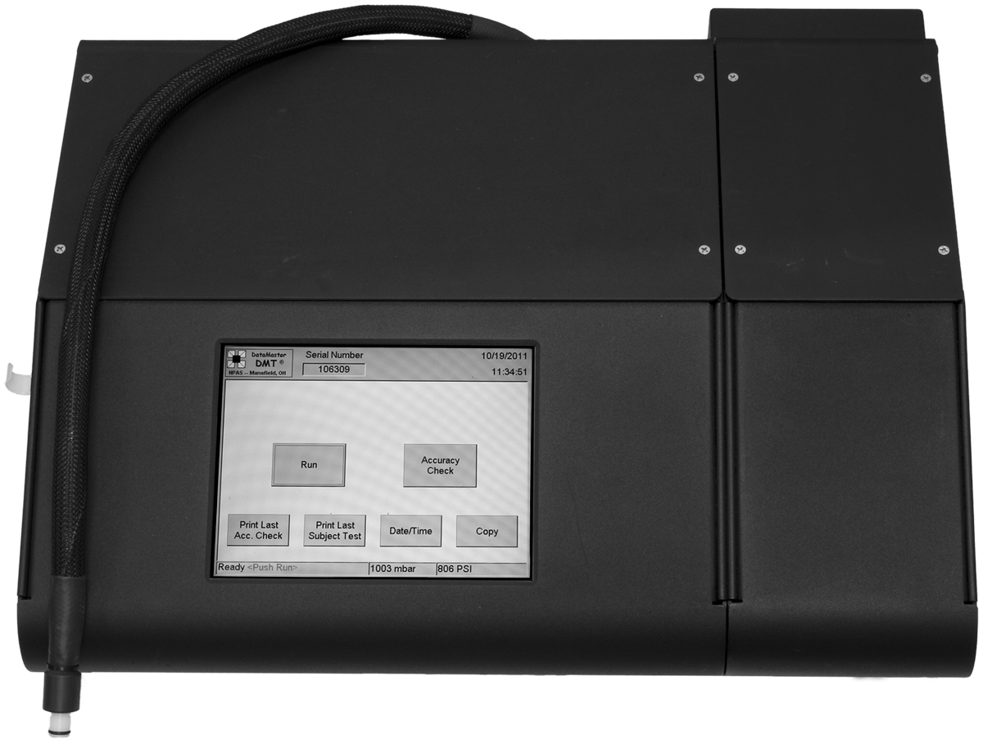

DATAMASTER DMT Functional Parts

DATAMASTER DMT Exterior Components

The functional parts of the DATAMASTER DMT are described as follows:

Touch Screen
The touch screen provides directions for operation of the instrument, and for navigating through the DATAMASTER DMT menus. The operator is prompted through each testing procedure step. Any error messages are also displayed.

Keyboard
The keyboard allows the operator to input data required for subject and accuracy checks.

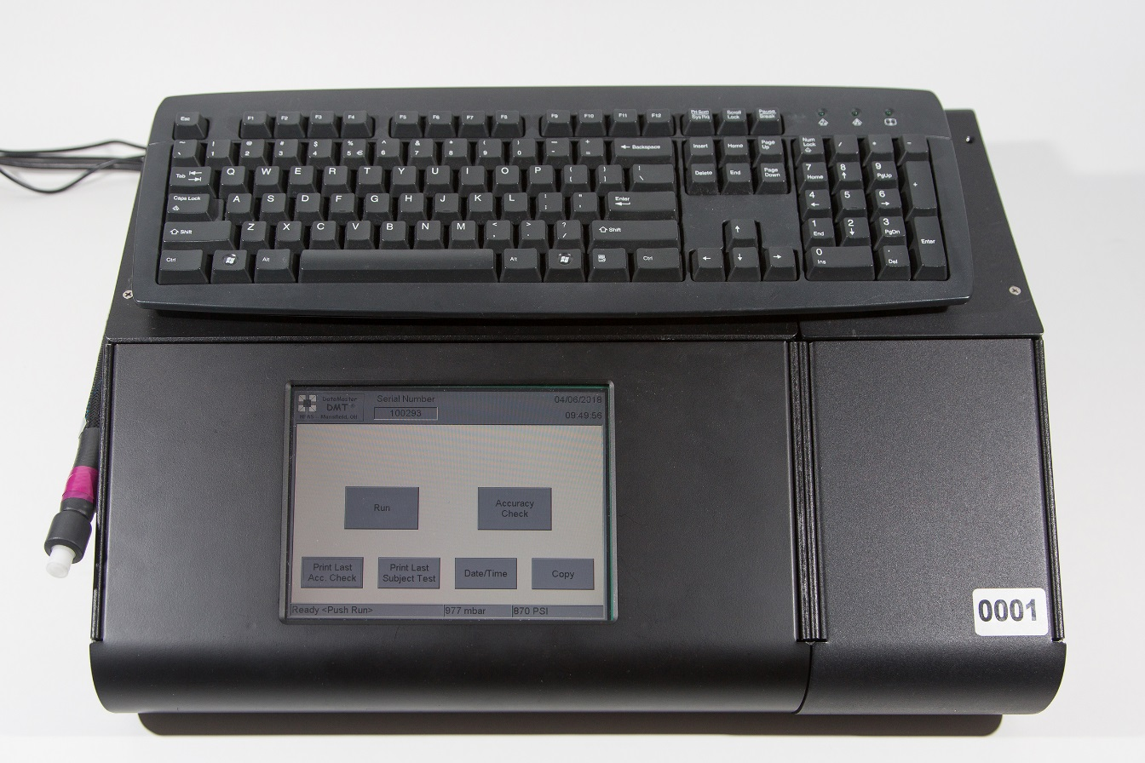
Breath Tube
The breath test tube is used to provide test samples into the instrument. A mouthpiece must be attached to the tube before use. The tube is semi-rigid and heated to avoid vapor condensation

Metal Cover
The metal cover protects the inner workings of the DATAMASTER DMT and is not to be removed.

DATAMASTER DMT Rear Panel

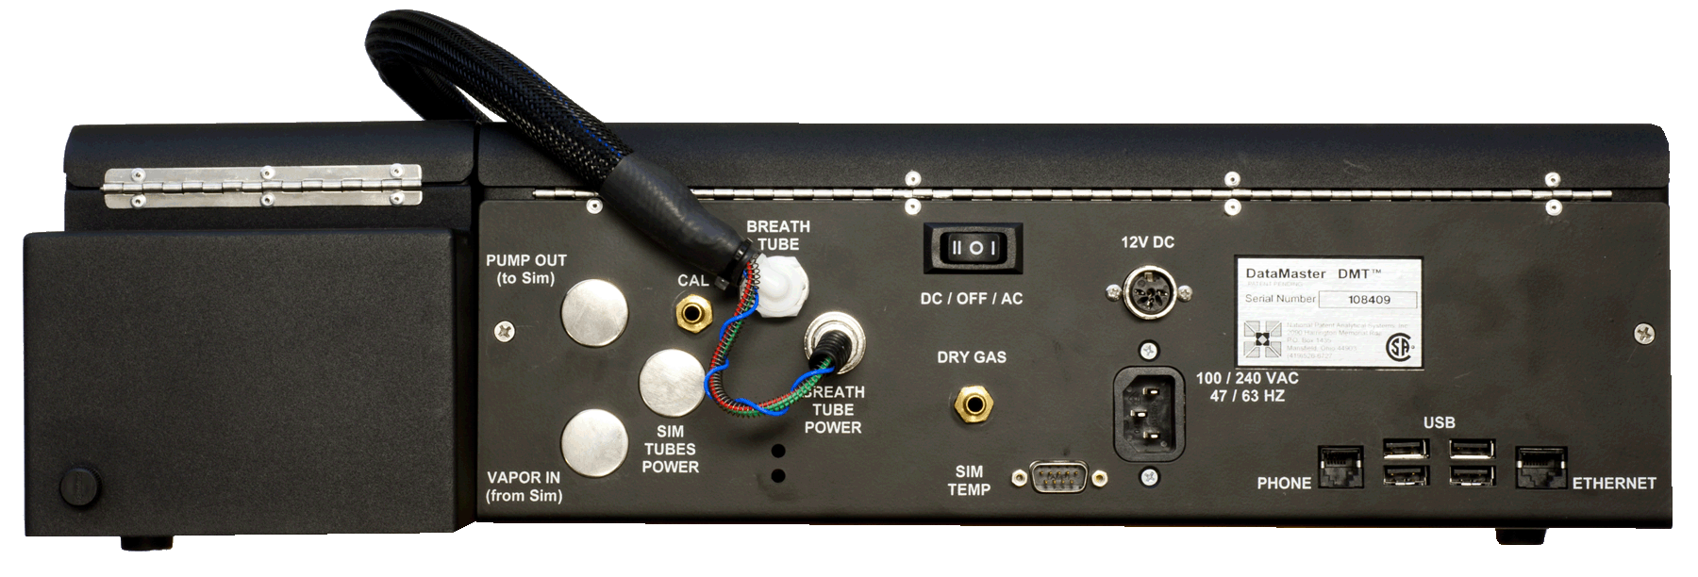
The functional parts of the DATAMASTER DMT rear panel are described as follows:

On/Off Switch
This toggle switch should be left ON always.

Power Supply
Use only the grounded power supply cable furnished with the instrument.

USB Ports
These ports are used to connect the keyboard and the printer to the DATAMASTER DMT. Do not use them to connect any other devices.

Ethernet Jack
This jack is for data transmission and is not currently being used in Michigan.

Telephone Jack
This jack is for data transmission and is not currently being used in Michigan.

Calibrate Port
During the “Purge” cycle on the DATAMASTER DMT, room air is drawn into the sample chamber via the “Breath Tube” and is expelled through this port by means of an internal pump.

Simulator Ports – Vapor in and Pump Out Ports
These two ports are not used in Michigan.

Dry Gas Port
This port is not used in Michigan.

Dry Gas Canister Cover
This covers the dry gas canister, which is used for accuracy checks.

Serial Number Plate
The serial number of the instruments is located on this plate.

DATAMASTER DMT PRINTER

The printer is a standard laser jet computer printer and is supplied with the DATAMASTER DMT. It is not to be used for anything other than the DATAMASTER DMT.

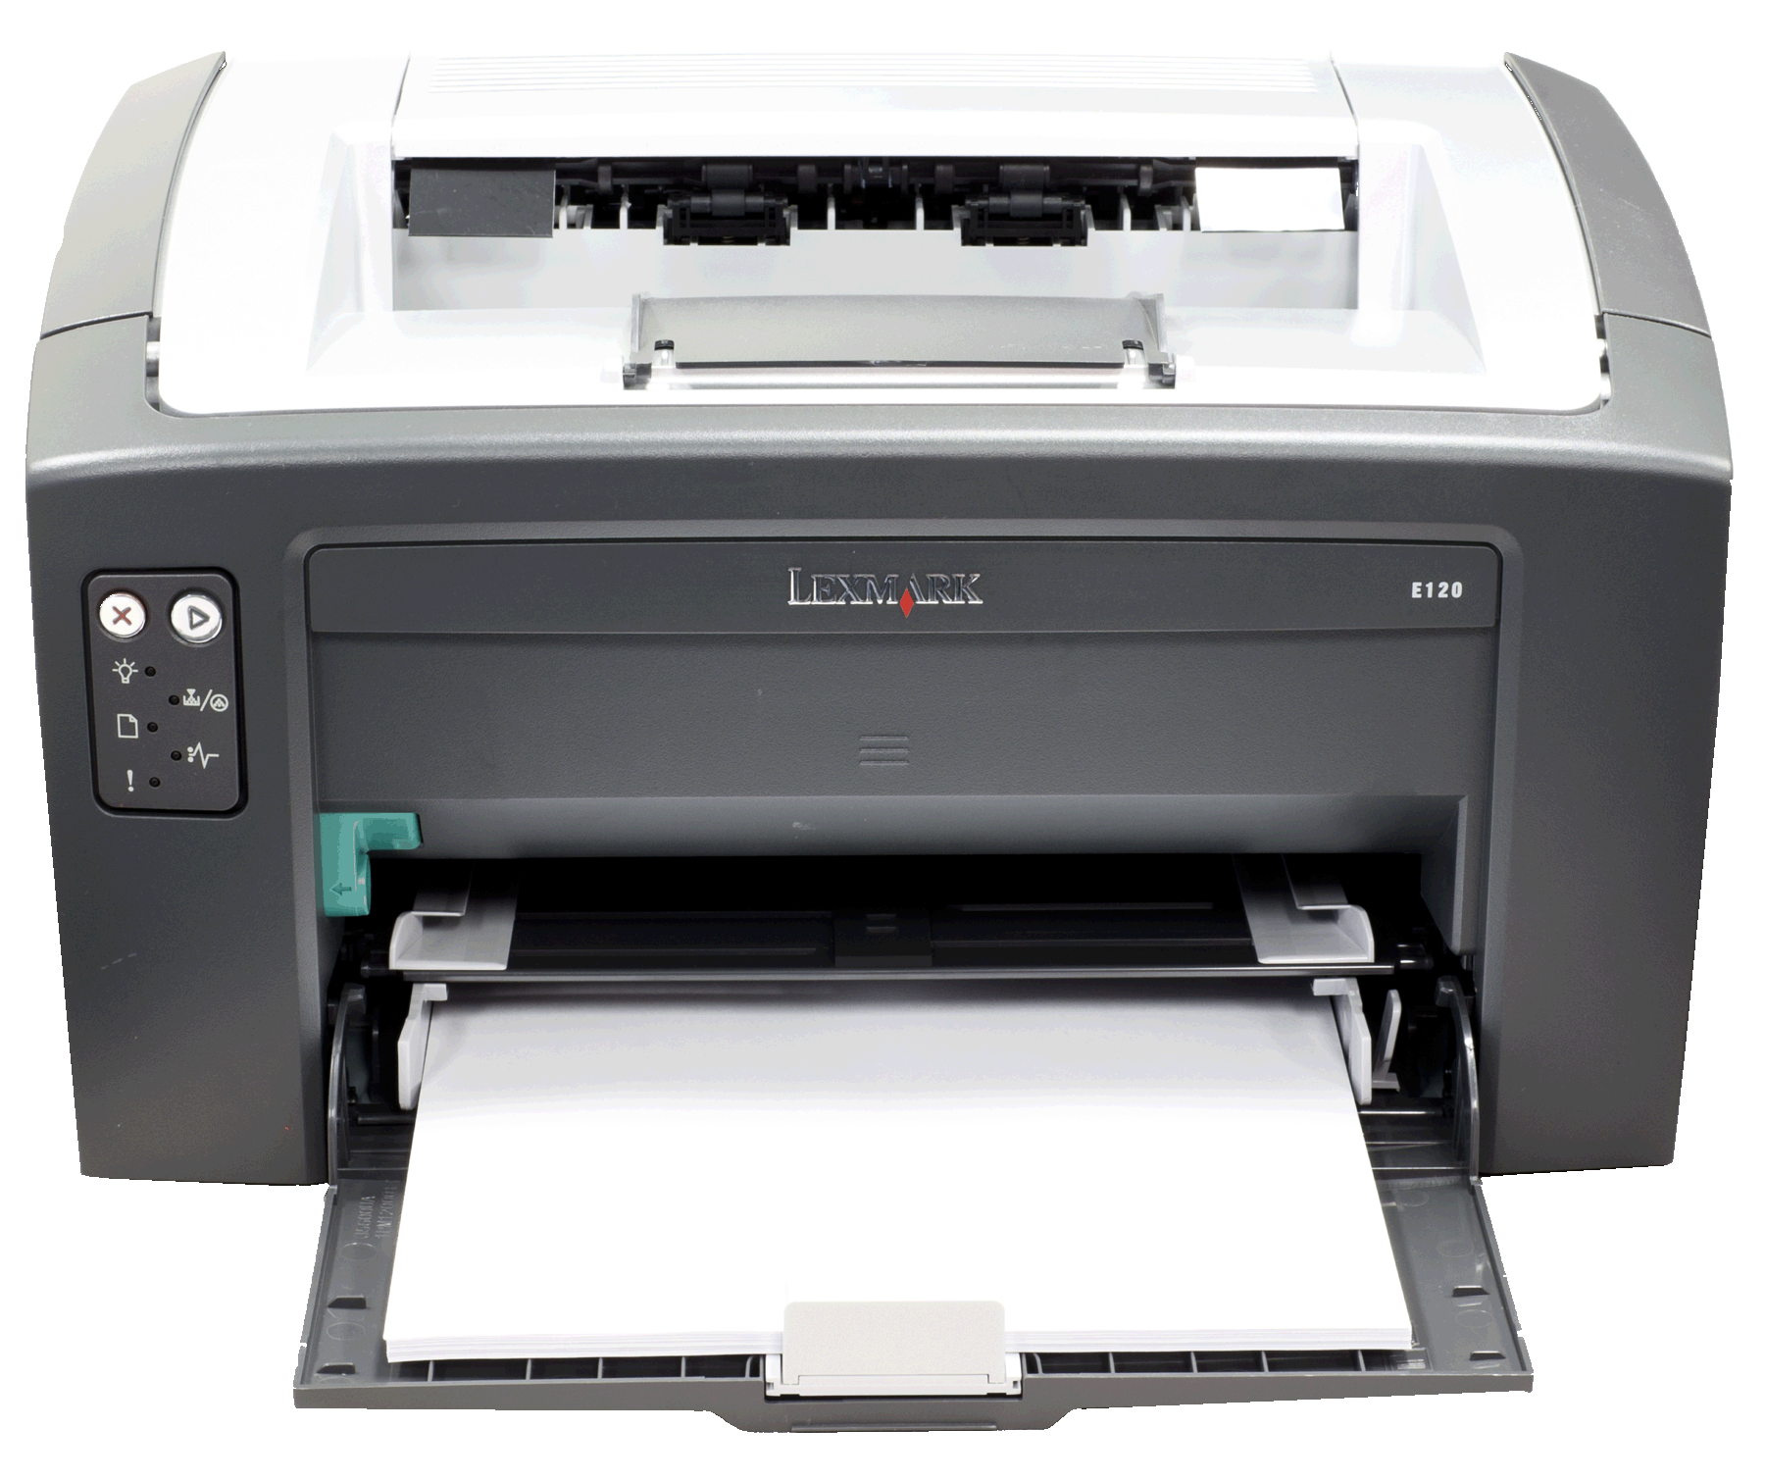

Subject Test Sequence

Step 1: The officer should check the mouth of subject for blood, food, gum, tobacco, or other foreign substances. Observe the subject for at least 15 minutes. The officer should use the time displayed on the instrument panel.

Step 2: The instrument will either be in the sleep mode or display the main menu. If it is in the sleep mode, touch the screen to get to the main menu.

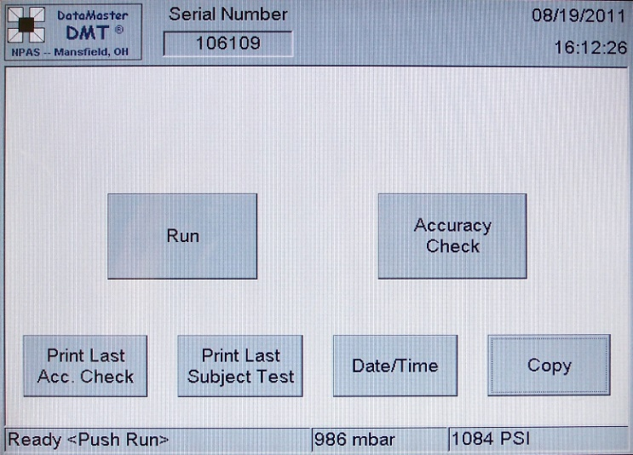
Main Menu display:

Step 3: Touch “RUN” button on the display.
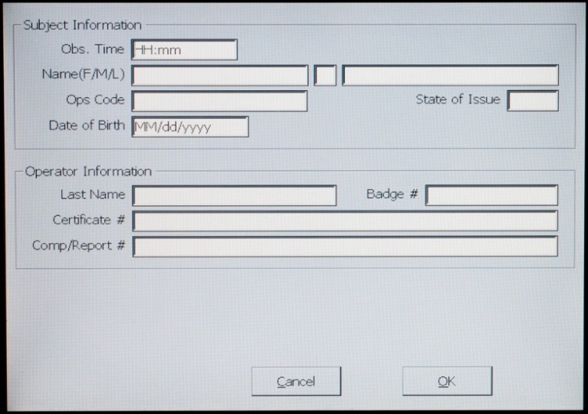
- This will bring up the Subject Information screen.
Step 4: The cursor will be in the “Obs. Time” box.
- Type in the observation start time using military time.

Step 5: Use the Tab key to move to the subject’s “Name” box.
- Type in the subject’s first name/middle initial/last name.
- Characters are allowed for the entire name. They may be:
a. A letter.
b. A hyphen (-).
Example: LUCILLE/S/SMITH-JONES
- If the subject’s name is unknown, type “UNKNOWN” in both the first and last name boxes.

Step 6: Use the Tab key to move to the “Ops “code.
- Type in the subject’s drivers’ license number.
- If driver’s license number is unknown, type “UNKNOWN.”

Step 7: Use the Tab key to move to the “State of Issue” box.
- Type in the two-letter state abbreviation.
Step 8: Use the Tab key to move to the “Date of Birth” box.
- Type in the date. “mm/dd/yyyy”.
- Eight (8) numerals must be entered. If an unrealistic date is entered the display will request a new date. If the Date of Birth is unknown, make no entry.

Examples:
Correct Incorrect
01/07/1956 1/7/1956
10/05/1942 10/5/1942
10/10/2001 15/35/1998

Step 9: Use the Tab key to move to the operator’s “Last Name” box.
- Type in the operator’s last name.
- Characters are allowed for the entire name. They may be:
a. A letter.
b. A hyphen (-).
Example: SMITH-JONES

Step 10: Use the Tab key to move to the “Badge #” box.
- Type in your Badge number.

Step 11: Use the Tab key to move to the “Certificate #” box.
- Type in your five-digit operator certification number.
- This is not the operators MCOLES number.

Step 12: Type in the report (complaint) number.
- If report number is unknown, do not enter anything. (Not a required field.)

Step 13: If the information entered is correct, touch the “OK” button.
- The DATAMASTER DMT will now proceed to the automatic test sequence.

Do not attach the mouthpiece or obstruct the flow of air into the breath tube.

Step 14: “TIMED PURGE”
All chambers and internal plumbing are cleansed of any residual substances by ambient (surrounding) air, which is pulled through the inlet (Breath) tube and pumped throughout the instrument by an internal pump.

CAUTION: The breath tube can act as a vacuum cleaner and suck in dust. It is recommended you lay the breath tube across the top of the instrument.

Only run a test when the area around the instrument is free from unusual odors. In the event of an unusual odor take appropriate corrective action (open a door, turn on fan, remove trash can). The instrument may stop the test sequence and display “Ambient Fail.”

Step 15: “AMBIENT ZEROING”
After the pump stops, the DATAMASTER DMT determines a zero-reference based on ambient air in the sample chamber. Three different filters with unique and known infrared bandwidths are used to separate ethanol from potential interference such as acetone.

Step 16: “BLANK TEST”
A reading is made of the checks conducted during “Ambient Zeroing.” A “Blank” test is conducted prior to any subject or accuracy check.

Step 17: “INTERNAL STANDARD”
This indicates the internal standard was checked.

During this cycle a quartz plate is inserted into the infrared path to ensure that the accuracy of the DATAMASTER DMT has not changed since the last calibration. Each DATAMASTER DMT is programmed to retain in memory the exact infrared absorption value of this quartz standard. The instrument measures the absorption of the quartz plate and compares this measured value with the value obtained at calibration. The two values must agree within prescribed limits or the operation will be aborted due to calibration error.
Step 18: “PLEASE BLOW” (flashing in the lower left corner of the display)
- A beeping signal indicates the DATAMASTER DMT is ready to accept a subject sample.

Step 19: Attach the mouthpiece to the breath tube.
- Open bag by tearing the plastic wrap, do not push the mouth piece through the plastic bag. Use the plastic bag to avoid touching the mouthpiece as you insert the mouthpiece into the breath tube.

Step 20: Position the subject near the instrument, and, if not handcuffed, have the subject place his or her hands behind his or her back so that the subject will not interfere with the test procedure.

Give clear instructions so the subject will understand how to provide an adequate breath sample.

The operator should advise the subject to:

“Place your mouth on the mouthpiece and blow long and steady into the tube until I tell you to stop.”

Once the subject starts to blow through the breath tube, the instrument’s beeping tone will change to a steady tone, and the green volume bar in the lower right corner of the screen will indicate breath volume. This shows that the instrument is receiving a sample.

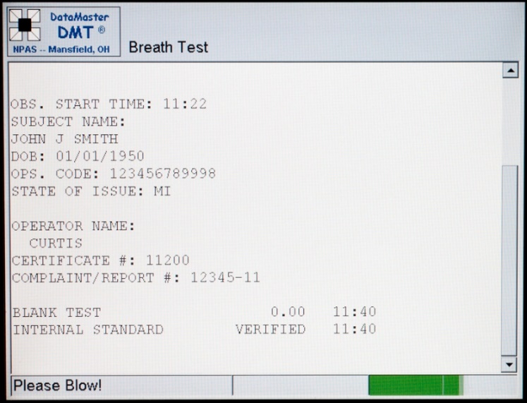
“Please Blow!” Breath Volume Bar

Allow the subject to expel all the air in his/her lungs before telling him/her to stop.

If the instrument does not produce the beeping sound and flash “Please Blow!” after the subject stops blowing, the breath sample has been accepted.

If the instrument continues to beep and flash “Please Blow!”, the sample was not accepted, and the subject must continue to provide a breath sample.

The subject has two minutes to provide a sample. The subject may start and stop blowing any number of times within the allowed two minutes.

Step 21: “Remove the mouthpiece and discard it” box will now appear.

Remove and discard the mouthpiece after the subject has finished providing the breath sample. After removing the mouthpiece touch the “OK” button.

The instrument will run another “Timed Purge”. Contamination of the ambient air may cause the instrument to stop the test sequence and display “Blank Error”.

Do NOT re-use a mouthpiece.

Do NOT attach a new mouthpiece or obstruct the flow of air into the breath tube during the “Timed Purge”.

Step 22: “ANALYZING”
- The instrument is now analyzing the result of the breath sample.

Step 23: “PURGING”
- Step 14 is repeated.

Step 24: “WAIT FOR NEXT TEST” - 120 Seconds
- The instrument counts down a two-minute wait between breath samples in the lower left corner.

Step 25: “AMBIENT ZEROING”
- Step 15 is repeated.

Step 26: “BLANK TEST”
- Step 16 is repeated.

Step 27: “PLEASE BLOW” (flashing in the lower left corner of the display)
- A beeping signal indicates the DATAMASTER DMT is ready to accept the second breath sample from the subject.
- Repeat Steps 19 through 21.

A new mouthpiece shall be used for each breath sample.

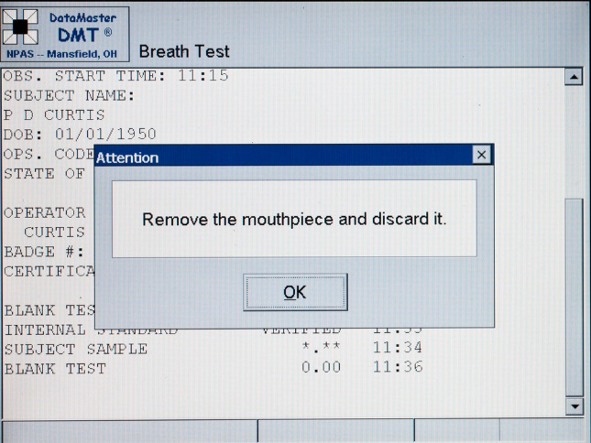
NOTE: If the second breath test result is not within the allowable variation of the first breath test result, the DATAMASTER DMT will automatically request a third breath test.

If so, Steps 22 through 27 will be repeated.

Step 28: “ANALYZING”
- Step 22 is repeated.

Step 29: “PURGING”
- Step 14 is repeated.

Step 30: “AMBIENT ZEROING”
- Step 15 is repeated.

Step 31: “BLANK TEST”
- Step 16 is repeated.

Step 32: “INTERNAL STANDARD CHECK” Error! Bookmark not defined.
- Step 17 is repeated.

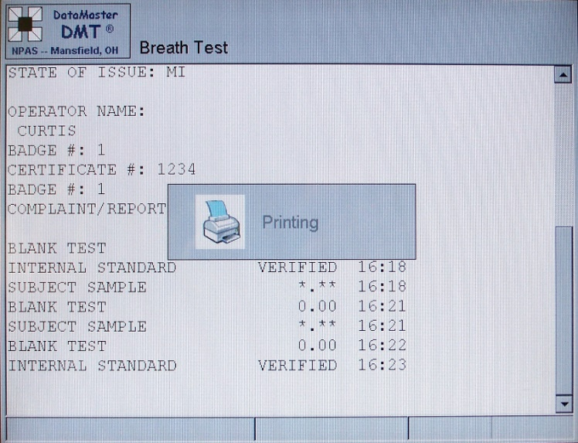
Step 33: A “printing” box will appear on the display as the instrument sends the test results to the printer.
The instrument will now return to the normal standby display screen.

Evidence Ticket distribution:
- One copy - Arresting officer.
- One copy - Forward to prosecutor’s office.
- One copy - Give to arrested subject.

Refusal/Incomplete Test

When the display “PLEASE BLOW” appears, the subject has two minutes to provide a sufficient breath sample. If the subject does not provide sufficient breath for analysis, the “Remove the mouthpiece and discard it” box will appear. Once the “OK” button is touched the touch screen will display the following dialog box:

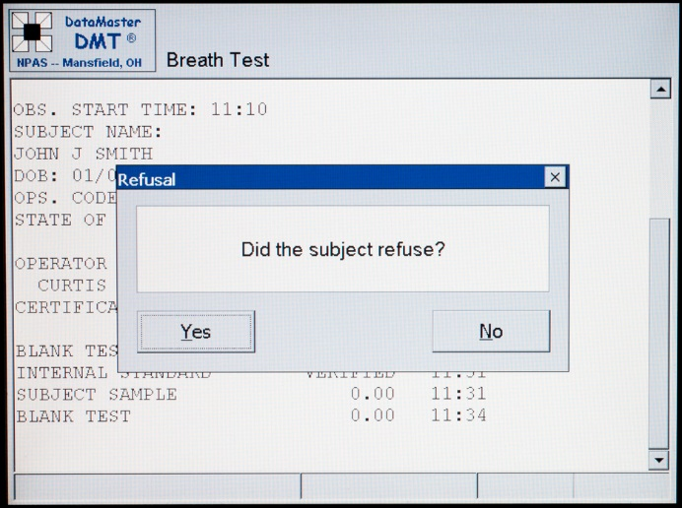
“DID THE SUBJECT REFUSE?” with a “YES” and “NO”

At this time, the operator has two choices. The “Yes” option will allow no additional breath sample opportunities, recorded as a refusal. The “No” option will allow an additional breath sample opportunity, recorded as an incomplete.

Refusals
If a refusal is warranted, the operator will touch the “YES” button. Steps 29 through 33 will be repeated. “Refused” will be printed on the subject sample test line of the Evidence Ticket/OD-80.

- Operator Refusal
In the event the subject “Refused” the first sample, the Evidence Ticket/OD-80 will print “Refused” on the subject sample line. “Operator Refusal” and “This is a SOS refusal” will be printed at the bottom of the Evidence Ticket/OD-80. The operator will need to obtain an alternative evidential test.

- Additional Sample Refusal
In the event the subject “Refused” the second or subsequent sample no further action is required. The evidence ticket/OD-80 will indicate the breath alcohol concentration for the provided sample(s) and “Refused” for the test sample which was not provided. The subject has met Implied Consent and not providing the additional sample does not constitute a Secretary of State refusal.

Incomplete Test
An “Incomplete Test” provides an operator with the opportunity to obtain an additional breath sample without having to re-start the test sequence.

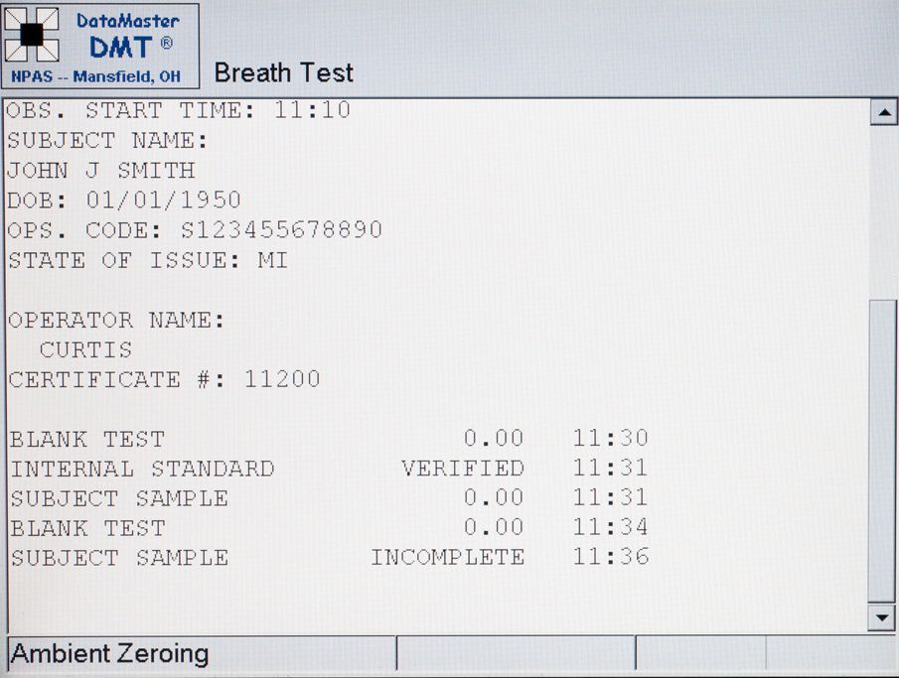
The instrument display will show “Incomplete” on the subject test line when the operator selects “NO”.

When the operator touches the “NO” button the instrument will resume the test sequence at Step 23 (Purging).

If the subject provides a sample the instrument resumes the normal testing sequence.

If the subject again fails to provide a sample the “Remove mouth and discard it” dialog box will appear. This will be followed by the “Did the Subject Refuse: Yes? or No?” dialog box.

The operator will choose “Yes” and the instrument will complete the test sequence as a refusal.

Operators are NOT required to offer additional sample opportunities.

Each time the instrument provides a sample opportunity the evidence ticket/OD-80 will provide one of three results:
1. The breath alcohol concentration.
2. Refused.
3. Incomplete.

In the event a sample is never obtained the operator will need to obtain an alternative evidential test.

Accuracy Checks

General Information

An accuracy check shall be performed on each instrument every calendar week. The type of accuracy check may be automatic or manual. Refer to the Administrative Rules for more detailed information.

Types of Accuracy Checks

1. Automatic Accuracy Check:

a. The DATAMASTER DMT will automatically run a dry gas accuracy check each calendar week. This occurs each Monday morning at approximately 0400 hours.

b. The automatic accuracy check test print-out (OD-80) shall be retained for record keeping purposes, at the agency in which the DataMaster resides.

- The accuracy check test result shall be logged on the OD-33 (Evidential Breath Testing Accuracy Check Log) by the designated DataMaster record keeper.

- If the instrument detects any problems during the automatic accuracy check, the test sequence will be stopped.

The instrument will automatically be removed itself from service.

A dialog box will initially appear on the touch screen indicating “DMT removed from service”.

“Out of service” will appear in the lower left corner of the touch screen. The instrument will intermittently beep. Advise the agency in which the DataMaster resides that it is “Out of service”.

A service technician will need to resolve the issue and place the instrument back in service.

2. Manual Accuracy Check:

- Do NOT perform a manual accuracy check unless told to do so by a service technician.

- The operator will need to touch the “Accuracy Check” button on the touch screen and enter the required information.

- The DATAMASTER DMT will run the accuracy check.

- The designated DataMaster record keeper shall place a copy of the OD-80 into the file for record keeping purposes.

- The designated DataMaster record keeper shall log the accuracy check on the OD-33 (Evidential Breath Testing Accuracy Check Log).

Manual Accuracy Check Sequence

The instrument will either be in the sleep mode or display the main menu. If it is in the sleep mode, touch the screen to get to the main menu.

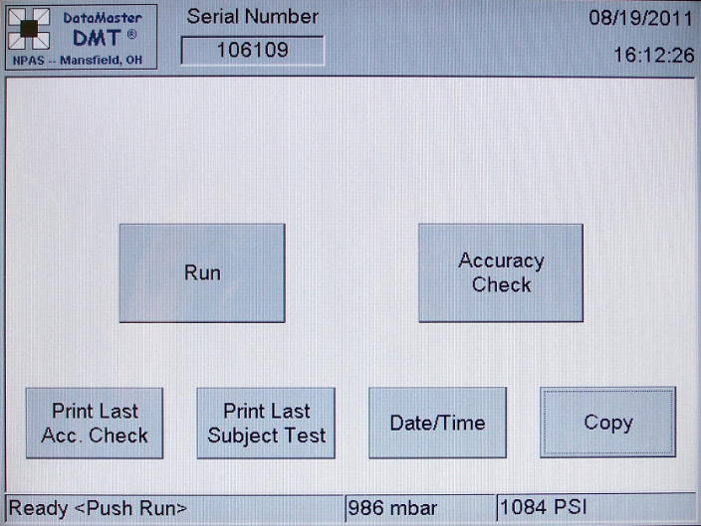
Main Menu display:

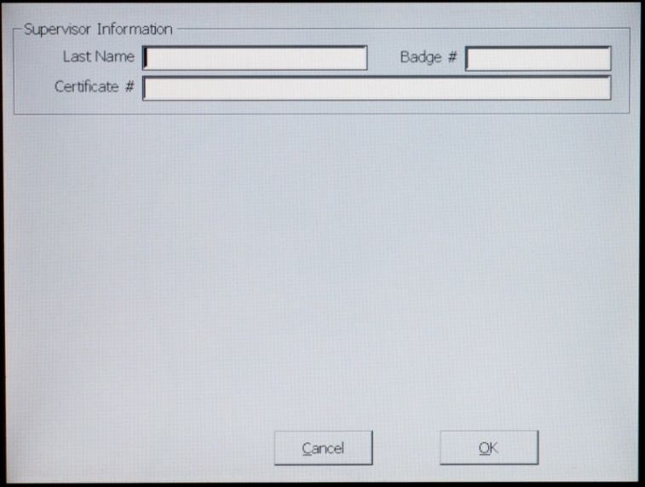
Step 1: Touch the “Accuracy Check” button or hit the F5 key on the keyboard. This will bring up the “Supervisor Information” screen. The cursor will be in the “Last Name” box.

Step 2: Type in the operator’s last name.

Characters are allowed for the entire name. They may be:

- A letter.
- A hyphen (-).
Example: SMITH-JONES

Step 3: Use the Tab key to move to the “Badge #” box”.

- Type in your Badge number.

Step 4: Use the Tab key to move to the “Certificate #” box”.

- Type in your five-digit operator certification number.

Step 5: Touch the “OK” button.

Step 6: The instrument will now run an accuracy check. The accuracy test printout (OD-80) shall be retained. File the test print out for record keeping purposes and log the result on the Evidential Breath Testing Accuracy Check Log (OD-33).

Accuracy Test Print Outs

Automatic Accuracy Test Manual Accuracy Test
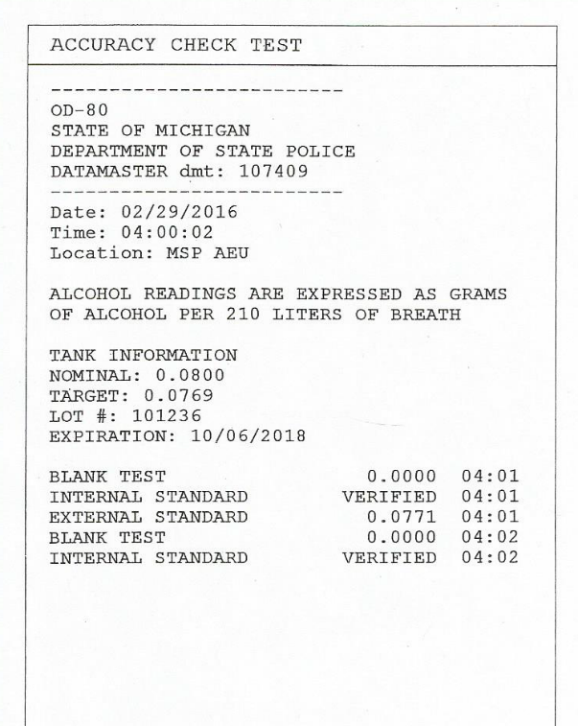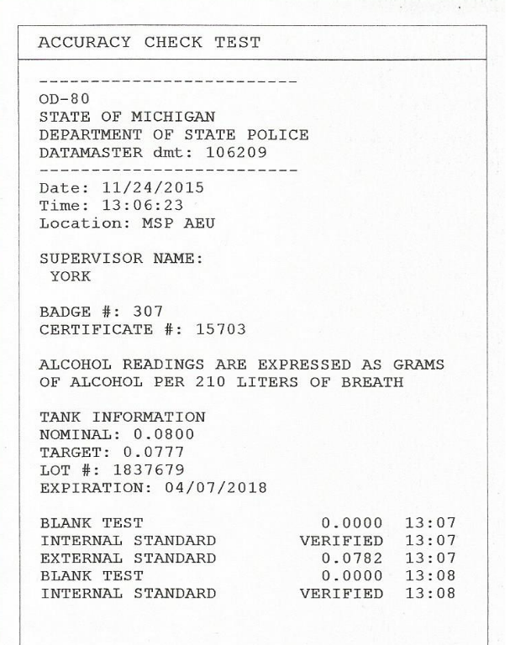

Display Messages

If any of the following messages appear on the display, do NOT take the unit out of service. A display message may be followed with additional information. In the event a display message is not followed by additional information the operator should run another test. If a problem persists, contact the service technician.

Invalid Sample

There are several reasons as to why an “INVALID SAMPLE” reading may be displayed on the instrument.
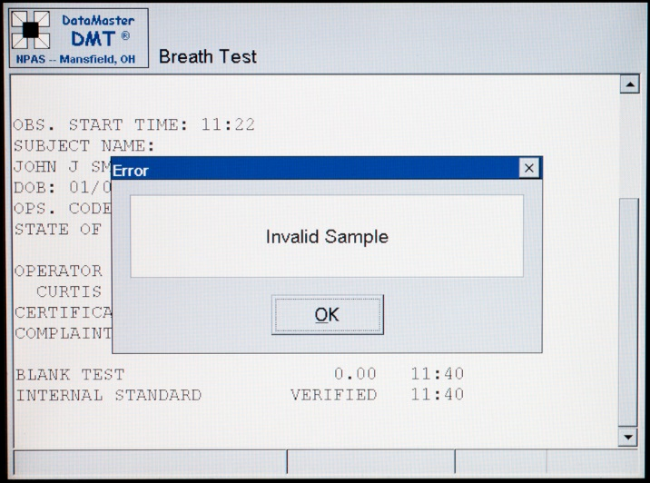

If, while the subject is blowing into the DATAMASTER DMT, he/she has a discontinuous breath flow, i.e. starts and stops blowing, or sucks back on the breath tube, the instrument may display “Invalid Sample.”

Residual mouth alcohol may also cause an “Invalid Sample” message. Scientific testing has shown that if the 15-minute observation period has been satisfied, then residual mouth alcohol is not the cause of the “Invalid Sample” result.

The officer’s observations of the subject while he/she is blowing into the instrument can provide the best explanation as to the cause of an “Invalid Sample.”

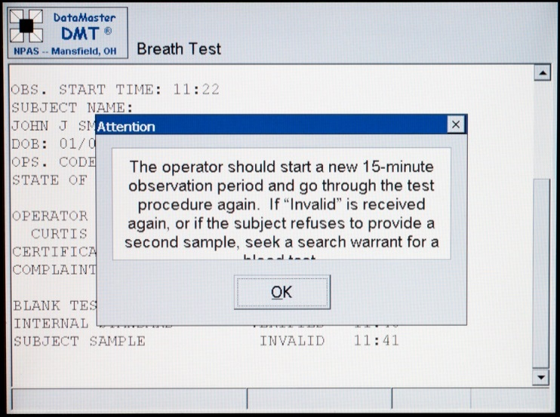
The operator should touch the “OK” button and should start a new 15-minute observation period and go through the test procedure again.

If “Invalid Sample” is received again, or if the subject refuses to provide a second sample, seek a blood test. Diabetics, hemophiliacs and people with medical conditions requiring the use of an anticoagulant are unable to give consent to the withdrawal of their blood. Under those circumstances a search warrant will be required.

This is not a SOS Refusal. Failure of the subject to provide the second sample cannot be regarded as a “Refusal” as the subject did provide a sample, pursuant to implied consent.

Chemical Interference

If the DATAMASTER DMT detects a chemical substance other than ethanol, the test will be aborted.

If the instrument gives an “Interference Detected” reading on the display, touch the “OK” button, and the printout will also indicate “Interference Detected.”

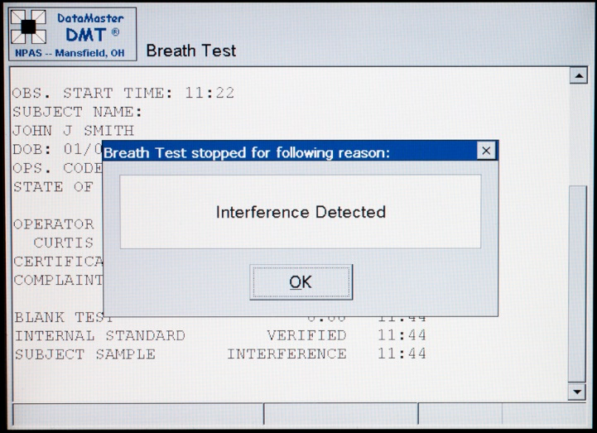
Once the “OK” button is touched the next screen will appear.

The operator should start a new 15-minute observation period and go through the test procedure again. If “Incomplete” is received again, or if the subject refuses to provide a second sample, seek a blood test. Diabetics, hemophiliacs and people with medical conditions requiring the use of an anticoagulant are unable to give consent to the withdrawal of their blood. Under those circumstances a search warrant will be required.

This is not a SOS Refusal. Failure of the subject to provide the second sample cannot be regarded as a “Refusal” as the subject did provide a sample, pursuant to implied consent.

Radio Frequency Interference

If the DATAMASTER DMT detects any radio transmissions in the area that could interfere with a test result, the test will be aborted.
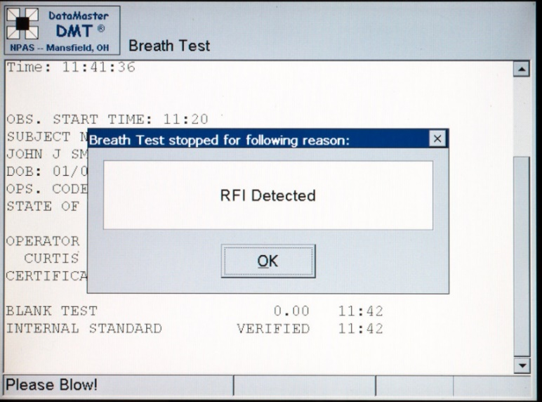
If the instrument gives an “RFI Detected” message on the display, touch the “OK” button, and the printout will also indicate “RFI Detected.”

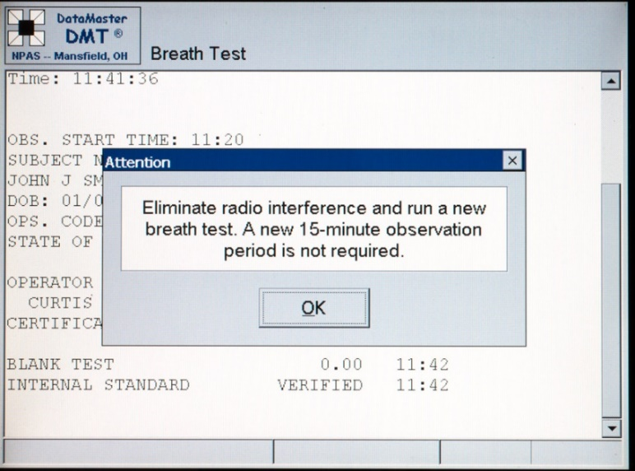
After the interference has been eliminated, touch the “RUN” button to initiate a new test. A new 15-minute observation Error! Bookmark not defined period is not necessary.

Ambient Fail

“Ambient Fail” will appear after the operator has started the test sequence by hitting “OK” on the Subject Information screen. If the subject reeks of alcohol have them move away from the instrument. Remove items around the instrument which have strong odors (i.e. the garbage). Other appropriate corrective action may be: open a door, turn on a fan, move the breath tube, etc. The operator should run another test.

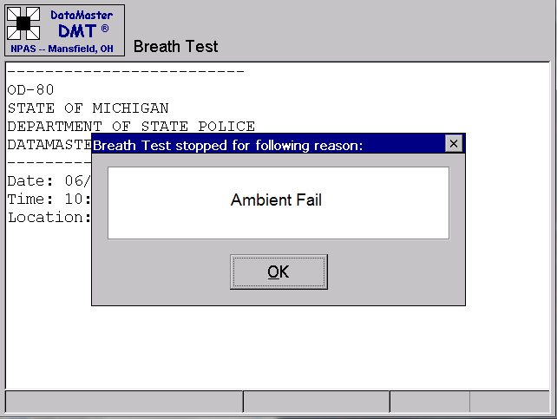

Blank Error

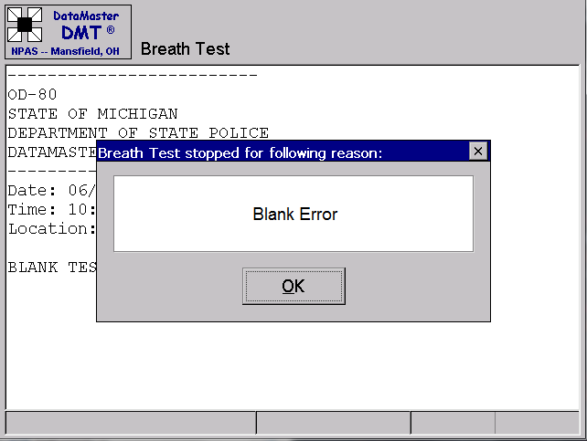
“Blank Error” will appear in the test sequence after a sample is provided and the operator has hit the “OK” button on the “Remove the mouthpiece and discard it” dialog box. Make sure the mouthpiece was not left attached to the breath tube. Remove items around the instrument which may have odors (i.e. the garbage). Other appropriate corrective action may be: open a door, turn on a fan, move the breath tube, etc. The operator should run another test.

Pump Error

This will appear any time when no air is being drawn into the instrument when the pump is turned on. Do not attach the mouthpiece or obstruct the breath tube opening whenever the pump is on. The operator should start a new test. If the problem persists, contact the service technician.

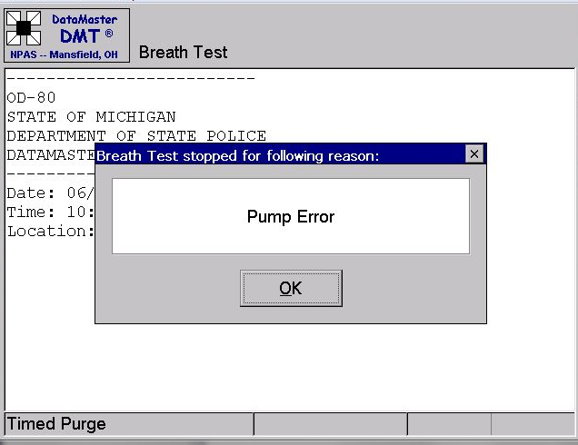

Print failed due to error

Check printer to ensure it is properly connected, has paper loaded in the tray, and ink.

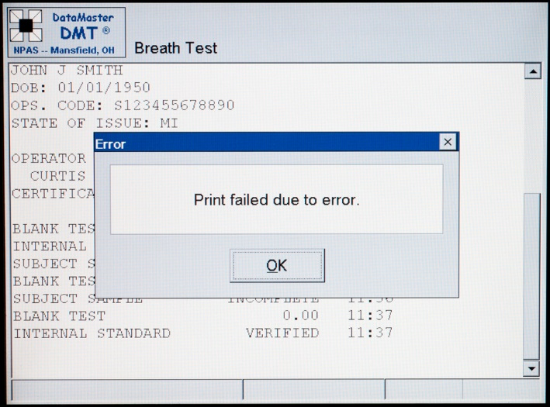

Start of observation time less than 15 minutes

This indicates the operator did not enter a valid observation start time. The operator must enter a time that is greater than 15 minutes before their attempt to start the test sequence.
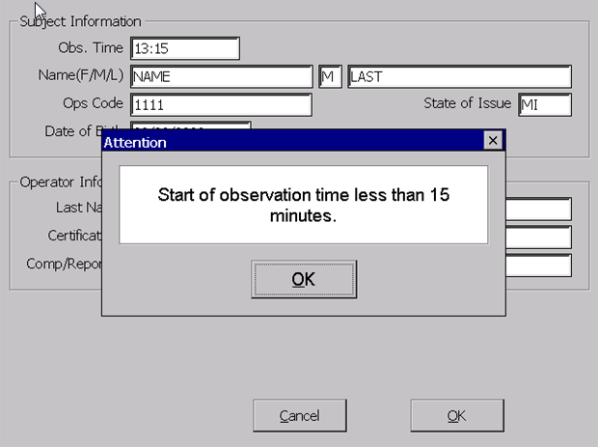

Standard Out of Range

This indicates the external standard used for the accuracy test is outside of the allowable range.

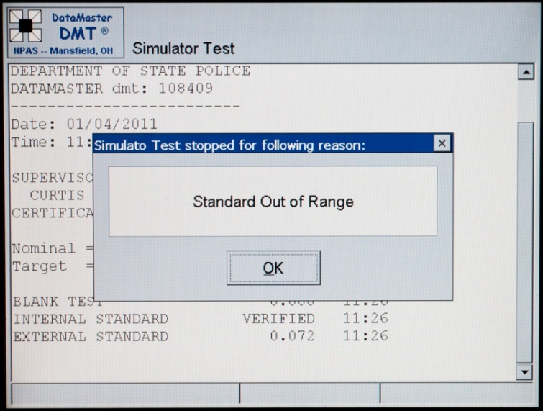

Out of Service

“Out of Service” will appear if the instrument has attempted to run an automatic accuracy check but has been unable to complete the process due to some type of problem. The instrument will have an audible “beep” when out of service.

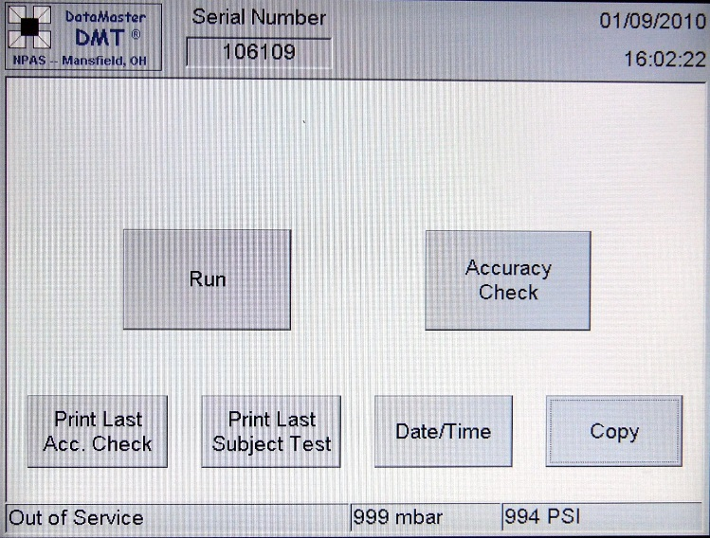
The agency in which the instrument is housed, will be required to contact a service technician for repair.

Sample Chamber not to temp

May appear after instrument is initially turned on. It will display “Please Wait” in the lower left corner. Wait until the instrument has time to get to proper operating temperature. If it will not come up to the proper temperature, contact the service representative.
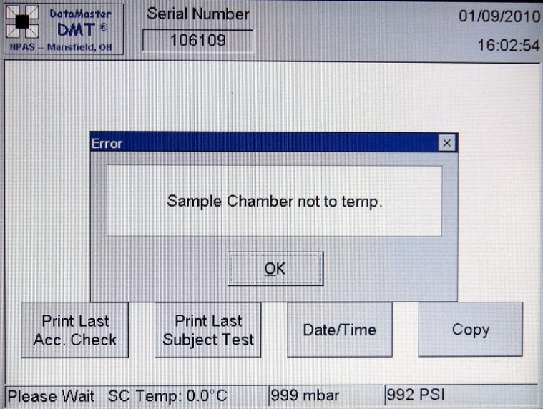

Breath Tube not to temp

This may appear after instrument is initially turned on. It will display “Please Wait” in the lower left corner. Wait until the instrument has time to get to proper operating temperature. If it will not come up to the proper temperature, contact the service representative.

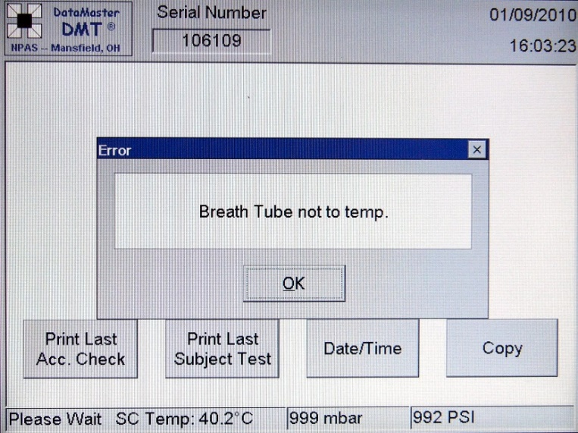

EVIDENCE TICKETS

Sample and Refusal Two Samples w/Incomplete
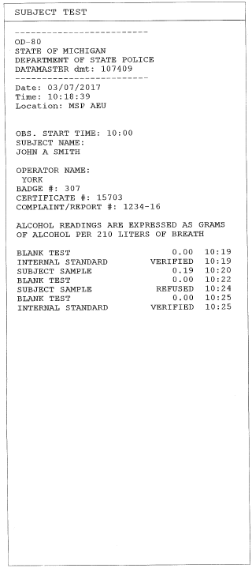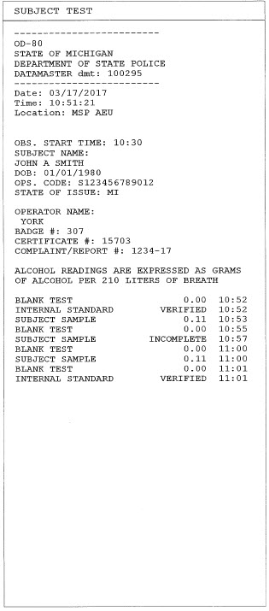

Operator Refusal Incomplete and Refusal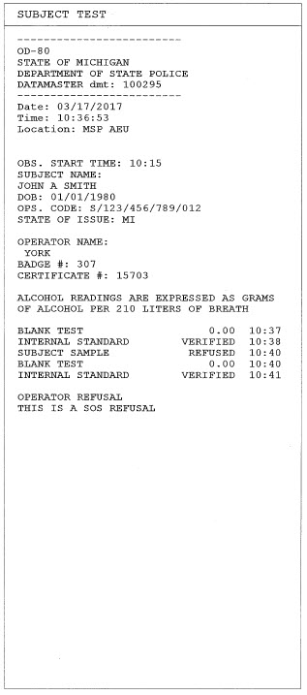 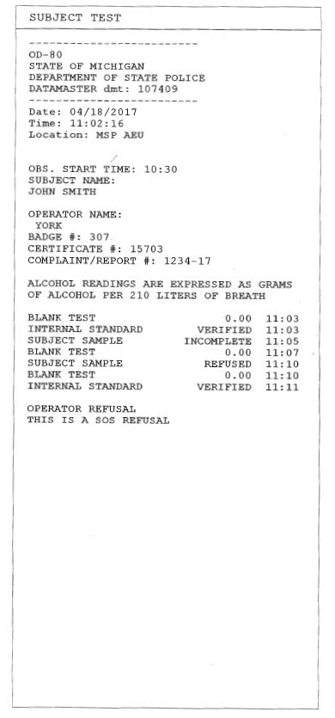

Invalid Sample Interference Detected
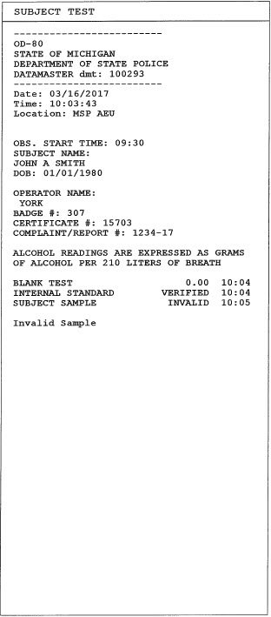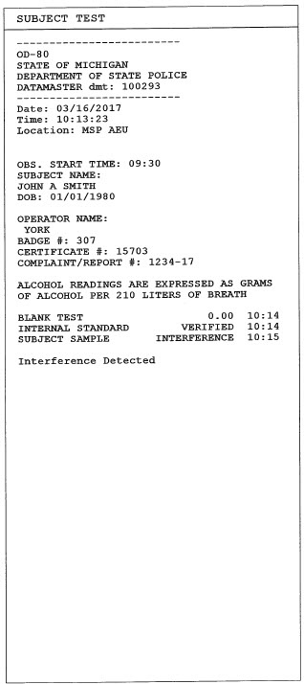

RFI Detected Blank Error
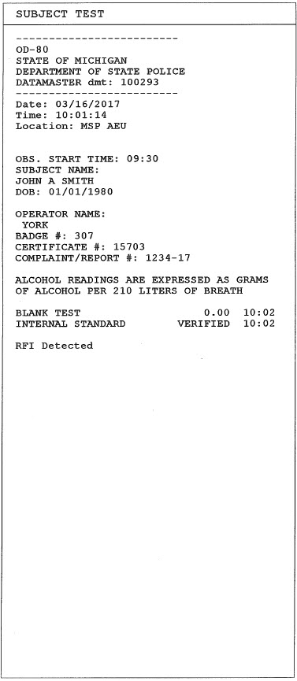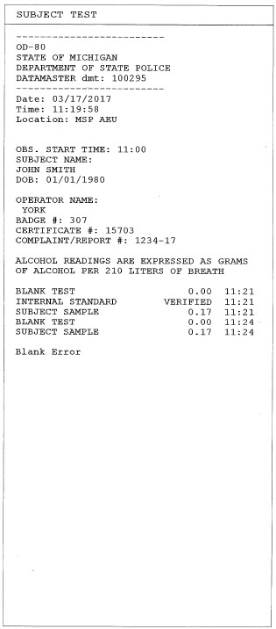

Date/Time Modifications

The instrument is set up to automatically make the adjustment for daylight savings time based on the second Sunday in March, and the first Sunday in November.

If an adjustment must be made to the time or date on the DataMaster DMT, the operator may make changes by performing the following steps

Step 1: Normal standby display:
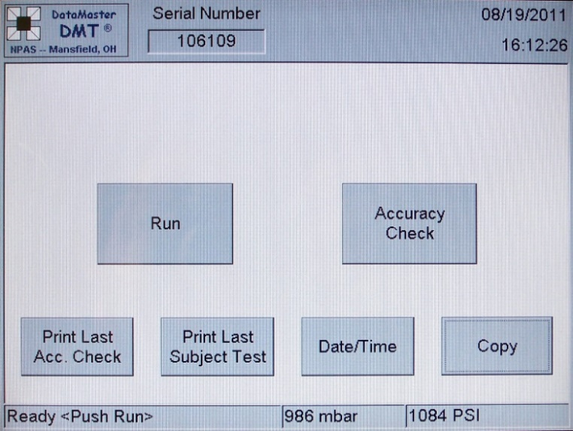

Step 2: Touch the “DATE/TIME” box in the bottom of the display.
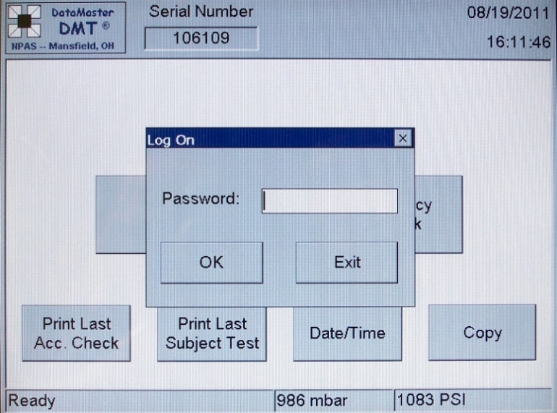
- This will bring up the “Password” screen.

Step 3: Type in “Time.”

Step 4: Touch the “OK” button.
- This will bring up the “Date/Time” box.

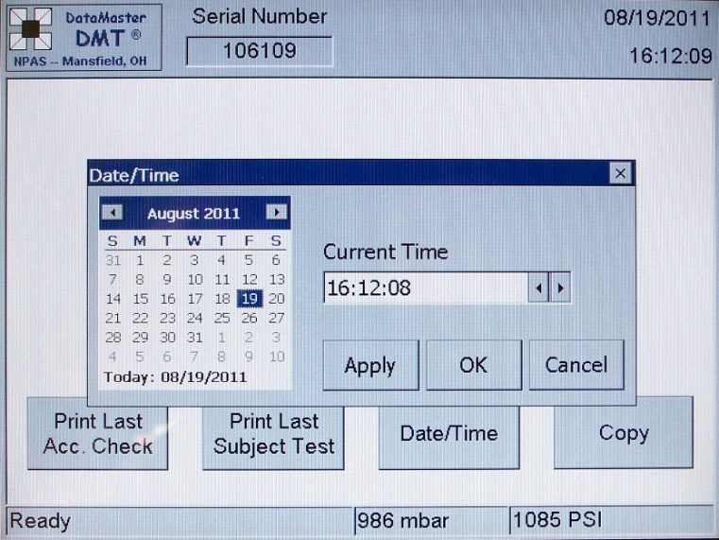
Step 5: Make the required changes using the keyboard and touch the “Apply” button.

Step 6: Touch “OK” button.
- This locks the setting and returns to the normal standby display.

Administrative Forms

OD-80 (Accuracy Check)

Whenever an accuracy check is performed on the DATAMASTER DMT, the OD-80 form shall be used to document the result.

INSTRUCTIONS FOR USE/RETENTION OF OD-80 (Accuracy Check):

1. Upon completion of the accuracy check the result will automatically print. This occurs every Monday morning at approximately 0400 hours.

2. The print-out is for the police department where the instrument is located.

3. The print-out is retained for current year plus one year.

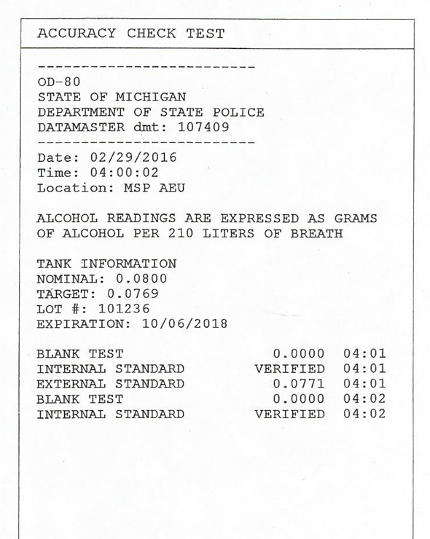

OD-80 (Subject Test)

Whenever a subject test is performed on the DATAMASTER DMT, the OD-80 form shall be used to document the results.

INSTRUCTIONS FOR USE/RETENTION OF OD-80 (subject test):

- Upon completion of the test three copies will automatically print:

  - One copy is the arresting agency.

  - One copy is to be given to the prosecutor.

  - One copy is to be given to the arrested subject.

- The printout is retained per the department’s retention policy.

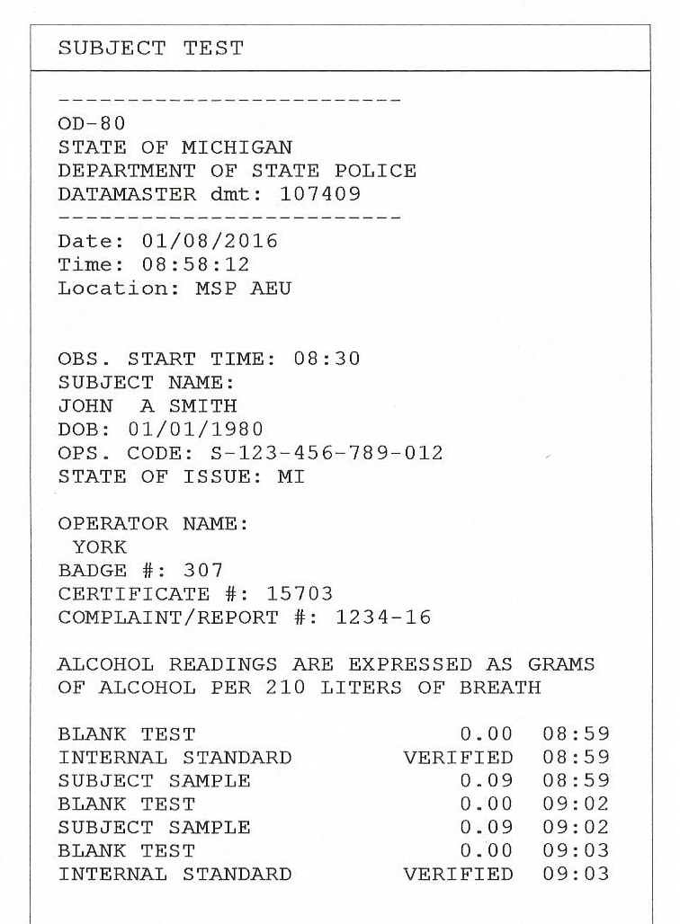

OD-80 (Accuracy Test)

OD-80 (Subject Test)

OD-33 Evidential Breath Testing Log

- Whenever the instrument or a certified operator performs an accuracy check, the result shall be entered on the Evidential Breath Testing Accuracy Check Log (OD-33).

- Service technicians will document maintenance work on the Evidential Breath Testing Accuracy Check Log (OD-33).

- If an instrument is taken out of service, an entry shall be made to that effect.

- Each log sheet shall contain entries for a one-month period.
- A new log sheet shall be used for each month.
- The log is retained for current year plus seven years.

INSTRUCTIONS FOR RECORDING AN ACCURACY CHECK:

All sections of the form must be completed. Specific instructions for each section are given below.

- Instrument Location - Enter the name of the department where the instrument is located.

- Instrument Number - Enter the six-digit serial number (not the MSP service tag number) for the instrument.

- ORI Number. - Enter the seven-digit number assigned to the department assigned responsible for the instrument.

- Month - Enter the current month.

- Year - Enter the current year.

- Dry Gas Alcohol Standard Lot Number/Expiration Date - Enter the lot number and expiration date. The information is on the Accuracy Check print out.

- Day - Enter the day of the month (1-31).

8. Operation Performed:

- Enter “Accuracy Check” for weekly test.

b. Enter “Out of Service” if the instrument is taken out of service. CHECK WITH A SUPERVISOR BEFORE MAKING THIS ENTRY. An “OUT OF SERVICE” ENTRY REQUIRES A SERVICE CALL.

- Target - Enter the four-digit target listed on the Accuracy Check print out.

- External Standard - Enter the four-digit external standard listed on the Accuracy Check print out.

- Operator ORI Number. - Enter seven-digit number assigned to the operator’s department when recording a manual accuracy check result.

- Certification Number. - Enter the five-digit number assigned to the certified Breath Test Operator who recorded the result. This is not the operators MCOLES number.

- Signature - Enter the signature of the certified Breath Test Operator who conducted the manual accuracy check or entered the automatic accuracy check result.

INSTRUCTIONS FOR SIGNING AT THE END OF THE MONTH:

At the end of each month, a supervisor or designee shall sign directly below the last log entry and enter the date and time.

- Supervisor/Designee Signature - A supervisor/designee shall sign his/her name after checking for proper log completion.

- Date - Enter the date the supervisor/designee check was completed in month, day, and year order.

OD-33 Form
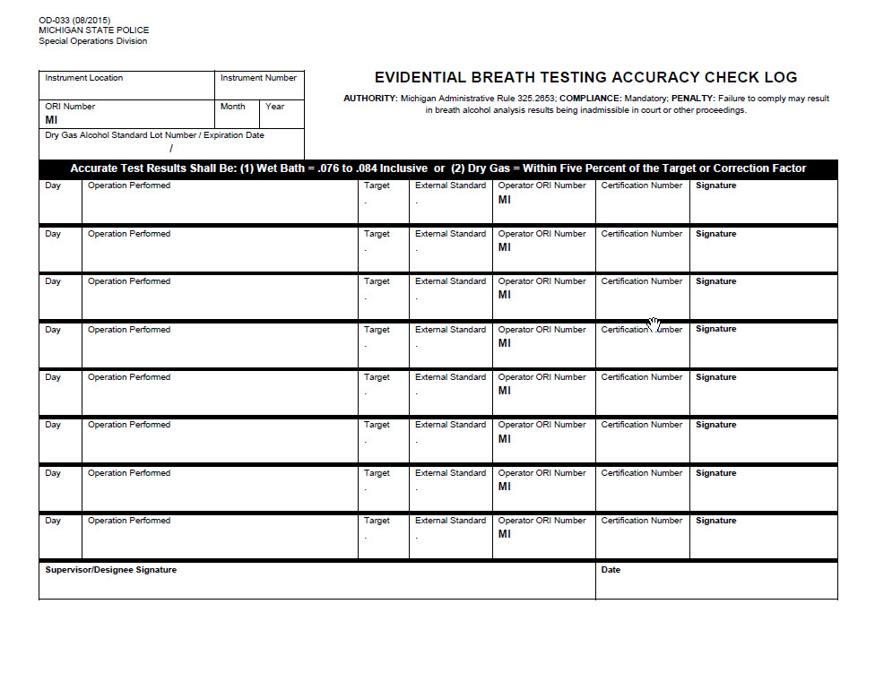

DI-93 Officer’s Report of Refusal to Submit to Chemical Test

1. The DI-93, Officer’s Report of Refusal to Submit to Chemical Test, is to be filled out by the arresting officer.

2. The Evidential Breath Test Operator is required to fill out only selected portions of the form.

INSTRUCTIONS FOR COMPLETION BY EVIDENTIAL BREATH TEST (EBT) OPERATOR:

The EBT Operator will need to fill out four boxes if the refusal deals with the actual breath test on the subject (i.e., technical refusal).

1. Breath Test Operator Number - Enter five-digit operator certification number.

2. Breath Test Operator Name - Enter the name of the operator who attempted to perform the breath test on the subject.

3. Badge Number - Enter the Breath Test Operator’s badge number.

- ORI Number - Enter the Breath Test Operator’s ORI number for his/her department.

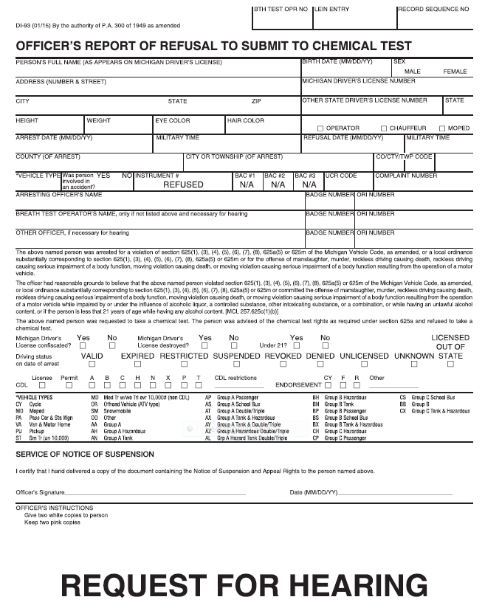
DI-93 Form

DI-177 Breath, Blood, Urine Test Report

1. The DI-177, Breath, Blood, Urine Test Report, is to be filled out by the arresting officer.

2. The EBT Operator is required to fill out only selected portions of the form.

INSTRUCTIONS FOR COMPLETION BY EBT OPERATOR:

Eight boxes need to be filled out by the evidential breath test operator.

- Breath Test Operator Number - Enter five-digit operator certification number.

- Instrument Number - Enter the DATAMASTER DMT serial number (not the MSP tag number).

- BAC #1 - Enter subject’s test result.

- BAC #2 - Enter second test if provided. If a sample is not obtained, leave blank.

- BAC #3 - Enter third test if needed. If sample is not obtained, leave blank.

- Breath Test Operator Name - Enter the name of the operator performing the breath test.

- Badge Number - Enter the Breath Test Operator’s badge number.

- ORI Number - Enter the Breath Test Operator’s ORI number for his/her department.

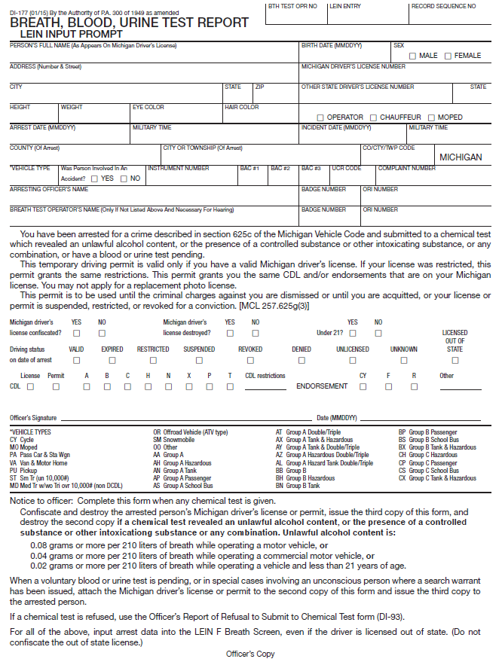
DI-177 Form

Courtroom Testimony

1. What is your name?

2. Where are you employed?

3. How long have you been an officer/deputy with ?

4. What is your assignment/duty?

5. Was this your assignment/duty on ?

6. How long have you been a DATAMASTER DMT operator?
- What was your previous assignment?
- How long?

7. Have you had any specialized training in administering tests on the DATAMASTER DMT?

8. When did you receive the training?

9. Where did you receive this training?

10. How long did you attend?

11. What did your training consist of?
- Laboratory and classroom exercises.

12. Were you tested to determine your degree of proficiency in the operation of the DATAMASTER DMT instrument?

13. Did you pass the examination(s) given as part of the course?

14. Were you issued a certification card for passing this course?

15. Do you have that certification card with you?

- Since the completion of the DATAMASTER DMT training course, how many occasions have you had to test people arrested for operating a motor vehicle under the influence of intoxicating liquor as part of your police duties?

17. Did all of these tests indicate that the persons tested were under the influence of intoxicating liquor?

18. Have you testified previously in court concerning your operation of the DATAMASTER DMT?

19. Approximately how many times have you testified concerning DATAMASTER DMT results?

20. As a certified DATAMASTER DMT operator, could you tell the jury what the DATAMASTER DMT instrument is?
- Infrared evidential breath alcohol test instrument manufactured by National Patent Analytical Systems, Inc. of Mansfield, Ohio.

21. Are you trained as a doctor?

22. Are you trained as a chemist?

23. Do you claim any expertise today beyond expertise in operating the DATAMASTER DMT?

24. What safeguards are required to ensure the accuracy of a test?
- Only certified operators may conduct tests on a subject.
- The instrument is checked at least once a week with a test standard containing a known alcohol concentration.
- A tested subject cannot have anything in his/her mouth for 15 minutes prior to the test.
- Two breath specimens from each subject are analyzed in succession.

25. Are there any records/logs kept concerning the use of the DATAMASTER DMT instrument?

26. Where are those records/logs kept?

27. Do you have the records with you that were kept on the instrument that was used to test the defendant on trial today?

28. Do they reflect whether or not the DATAMASTER DMT instrument has been given its weekly accuracy checks?

29. Do the records reflect whether or not the instrument has been given its inspection every 120 days as required?

30. Is there a prescribed method followed in performing a DATAMASTER DMT test?

31. What is this method?

32. Do you know , the defendant in this case?

33. Do you see him/her in the courtroom?

34. Would you describe and point him/her out for the jury/court?

35. On , did you administer a breath test to the defendant on the DATAMASTER DMT instrument?

36. Prior to giving the test to the defendant, did you advise the defendant of anything?

37. What did you advise the defendant?
- Chemical test rights.
- The test will require two breath samples.
- Place your mouth on the mouthpiece and blow long and steady into the tube until I tell you to stop.

38. When and where did you give the defendant this test?

39. How long was the defendant under your observation before you administered the test?

40. During that time, did the defendant have anything to eat, drink, or smoke?

41. Did you ask the defendant any questions?

42. How many tests did you give the defendant on the DATAMASTER DMT?

43. Did you follow the prescribed method in testing the defendant?

44. Let me show you a document that has been marked as People’s Proposed Exhibit ________. Can you identify it for the jury/court?
- Evidence ticket.

45. Is this the document you kept regarding the test results of the defendant?

46. What was the result of the first breath alcohol test that you conducted on this defendant?

47. What was the result of the second breath alcohol test that you conducted on this defendant?
- Move for admission of the document indicating the test results of the defendant.

48. As a result of these tests, do you have an opinion as to the condition of the defendant at the time you administered them?

49. Will you state this opinion to the jury/court?

50. Based on your observation of the defendant’s behavior prior to and during the time of the test, do you have an opinion as to the sobriety of the defendant?

51. On what do you base that conclusion?

Administrative Rules

DEPARTMENT OF STATE POLICE

TRAINING DIVISION

TEST FOR BREATH ALCOHOL

Filed with the Secretary of State on January 16, 2018.

These rules take effect immediately upon filing with the Secretary of State unless adopted under sections 33, 44, or 45a(6) of 1969 PA 306. Rules adopted under these sections become effective 7 days after filing with the Secretary of State.

(By authority conferred on the department of state police by section 190 of 1945 PA 327, MCL 259.190, and section 625a of 1949 PA 300, MCL 257.625a)

R 325.2651, R 325.2652, R 325.2653, R 325.2654, R 325.2655 are amended and
R 325.2656, R 325.2657 are rescinded to the Michigan Administrative Code as follows:

R 325.2651 Definitions.
Rule1. (1) As used in these rules:
(a) "Acts" means 1945 PA 327, MCL 259.190, 1949 PA 300, MCL 257.625a, 1993 PA
354, MCL 462.359, 1994 PA 451, MCL 324.80181, MCL 324.81136, and MCL
324.82137.
- "Alcohol standard" means a certified alcohol standard.
- "Calendar month" means 12:01 a.m. on the first date of any of the 12 named months of the year to midnight on the last date of the same month.
- "Calendar week" means 12:01 a.m. Sunday to midnight Saturday.
- "Class" means a classification of operator status as certified by the department, based on training and function as specified in R 325.2658.
- "Department" means the department of state police.
- "Equipment" means evidential and preliminary breath alcohol test instruments, simulator devices, calibration stations, forms, and any accessories and supplies necessary for compliance with the procedures in these rules or law.
- "Evidential breath alcohol analysis" means chemical analysis of an essentially alveolar breath sample that indicates a specific result in grams of alcohol per 210 liters of breath.
- "Evidential breath alcohol test instrument" means an evidential breath testing device that indicates a specific result in grams of alcohol per 210 liters of breath.
- "Preliminary breath alcohol analysis" means chemical analysis of essentially alveolar breath samples that indicates the presence or absence of alcohol in a person's blood.
- "Preliminary breath alcohol test instrument" means a breath alcohol screening device that indicates the presence or absence of alcohol in a person's blood.
- "Shall" means that a function is mandatory.
- "Should" means that a function is recommended, but not mandatory, with reasonable deviation allowed.
(2) Terms used in the acts have the same meanings when used in these rules.

R 325.2652 Approved equipment.
Rule2. (1) Evidential and preliminary breath alcohol test instruments shall be tested by, and shall meet the existing model specifications for evidential breath alcohol analysis as established by, the United States Department of Transportation, National Highway Traffic Safety Administration. The specifications, identified as "Model Specifications for Evidential Breath Testing Devices," 49 FR 48855 et seq., (December 14, 1984), as amended by 58 FR 48705 et seq., (September 17, 1993), 62 FR 43416 et seq., (August 13, 1997), 69 FR 42237 et seq., (July 14, 2004), 71 FR 37159 et seq., (June 29, 2006), 72 FR 71480 et seq., (December 17, 2007) and FR Doc. 2012-14582 (June 14, 2012) are adopted in these rules by reference. A copy of the specifications and a current conforming products list are available from the U.S. Department of Transportation, National Highway Traffic Safety Administration, 1200 New Jersey Avenue SE, Washington, D.C. 20590, or from the Michigan State Police, Training Division, 7150 Harris Drive, P.O. Box 30634, Lansing, MI, 48909.
- If the United States Department of Transportation discontinues the testing of evidential breath alcohol test instruments or the issuance of model specifications for such testing, only those instruments tested and approved by the department shall be used.
- An application for equipment approval shall be submitted to the department.
- Only equipment approved by the department for evidential and preliminary breath alcohol analysis shall be utilized by operators.

R 325.2653 Equipment accuracy.
Rule 3. (1) An appropriate class operator who has been certified in accordance with R 325.2658 shall verify an evidential breath alcohol test instrument for accuracy at least once each calendar week, or more frequently as the department may require. Alternatively, a pre-programmed self-test for accuracy may be initiated by the evidential breath alcohol test instrument and recorded by an appropriate class operator who has been certified in accordance with R 325.2658 if the instrument is so equipped and programmed. The tests for accuracy are not required to be performed within 7 days of each other. The test for accuracy shall be made using an alcohol standard that is approved by the department. For the evidential breath alcohol test instrument to meet the requirements for accuracy, a test result not exceeding +/- 5% shall be obtained when using a controlled device. Controlled devices include both of the following:
  - Wet bath device that delivers an alcohol vapor concentration test result of .080 grams of alcohol per 210 liters of vapor.
  - Compressed alcohol gas device that delivers a test result of .080 grams of alcohol per 210 liters of vapor after applying applicable altitude or topographic elevation correction factor supplied by the manufacturer. The correction factor may be applied by the operator or by the evidential breath alcohol test instrument if so pre-programmed.
- An appropriate class operator who has been certified in accordance with R 325.2658 shall verify for accuracy a preliminary breath alcohol test instrument at least monthly, or more frequently as the department may require. The test for accuracy shall be made using an alcohol standard that is approved by the department. For the preliminary breath alcohol test instrument to meet the requirements for accuracy, a test result not exceeding

+/- 5% shall be obtained when using a controlled device. Controlled devices include both of the following:
  - Wet bath device that delivers an alcohol vapor concentration of .080 grams of alcohol per 210 liters of vapor.
  - Compressed alcohol gas device that delivers a test result of .080 grams of alcohol per 210 liters of vapor after applying applicable altitude or topographic elevation correction factor supplied by the manufacturer. The correction factor may be applied by the operator or by the preliminary breath alcohol test instrument calibration station if so pre- programmed.
- Approved evidential breath alcohol test instruments shall be inspected, verified for accuracy, and certified as to their proper working order within 120 days of the previous inspection by either an appropriate class operator who has been certified in accordance with R 325.2658 or a manufacturer-trained representatives approved by the department.

R 325.2654 Equipment repair and service.
Rule 4. (l) The repair and service of equipment approved by the department for evidential and preliminary breath alcohol analysis shall be at the expense of the agency using the equipment. The department or the agency using the equipment may arrange to have this service provided either by an appropriate class operator who has been certified in accordance with R 325.2658 or a manufacturer-trained authorized representatives approved by the department.
- After repair or service and before being placed in service, evidential and preliminary breath alcohol test instruments shall be verified for accuracy in accordance with the provisions of R 325.2653 and records of verification shall be kept as required by the department.

R 325.2655 Techniques and procedures.
Rule 5. (1) A procedure that is used in conjunction with evidential breath alcohol analysis shall be approved by the department and shall be in compliance with all of the following provisions:
  - Except as provided otherwise in these rules, evidential breath alcohol test instruments shall only be operated by appropriate class operators who have been certified in accordance with R 325.2658.
  - All analyses shall be conducted following procedures approved by the department and using forms approved by the department as required.
  - Records of operation, analyses, and results shall be maintained at the evidential breath alcohol test instrument location as prescribed by the department, and copies forwarded to the department as required.
  - The department shall test samples from each lot of alcohol standards used in the state in conjunction with evidential breath alcohol test instruments. The department shall certify for use those lots of alcohol standards that are found to be proper in chemical composition.
  - A person may be administered an evidential breath alcohol analysis on an evidential breath alcohol test instrument only after being observed for 15 minutes before collection of the breath sample by at least 1 appropriate class operators who is certified in accordance with R 325.2658. The observation period may be conducted by more than 1 operator working in concert. During the observation period, the person shall not have smoked, regurgitated, or placed anything in his or her mouth, except for the mouthpiece associated with the performance of the evidential breath alcohol analysis. The operator need not stare continuously at the person, but must be close enough to be aware of the person's actions and conditions. The operator may complete paperwork, enter data into the evidential breath alcohol test instrument, or conduct other reasonable tasks during the observation period provided the person is within the operator's field of vision. Breaks in the observation period lasting only a few seconds do not invalidate the observation provided the operator can reasonably determine that the person did not smoke, regurgitate, or place anything in his or her mouth during the breaks in the observation.
  - The operator shall request a second evidential breath alcohol from the person being tested and administered, unless the person refuses to give the second breath sample or a substance is found in the person's mouth subsequent to the first evidential breath alcohol analysis that could interfere with the breath sample result. Obtaining the first breath sample result is sufficient to meet the requirements for evidentiary purposes prescribed in section 625c of 1949 PA 300, MCL 257.625c. The purpose of obtaining a second breath sample result is to confirm the result of the first breath sample result. A second breath sample result shall not vary from the first breath sample result by more than the allowable variation listed in Table 1.

Table 1
Breath alcohol allowable variation of second breath sample result range from the first breath sample result
0.00 - 0.14 +/- 0.01
0.15 - 0.24 +/- 0.02
0.25 - 0.34 +/- 0.03
0.35 - or more +/- 0.04

If the variation is more than that allowed in Table 1, the operator shall request a third breath sample from the person being tested and a third breath sample result may be obtained. If the third breath sample result does not conform to the allowable variation in Table 1 of either of the first 2 tests, the person shall be requested to submit a blood or urine sample for analysis in accordance with MCL 257.625a and the procedures established in R 325.2671 to R 325.2677.
  - The results of an evidential breath alcohol analysis of a person's breath shall be expressed in terms of grams of alcohol per 210 liters of breath, truncated to the second decimal place. For example, 0.237 found shall be reported as 0.23.
- A procedure that is used in conjunction with preliminary breath alcohol analysis must be approved by the department and shall be in compliance with all of the following provisions:
- Except as provided otherwise in these rules, preliminary breath alcohol test instruments shall only be operated by appropriate class operators who have been certified in accordance with R 325.2658
- A person may be administered a preliminary breath alcohol analysis on a preliminary breath alcohol test instrument only after the operator determines that the person has not smoked, regurgitated, or placed anything in his or her mouth for at least 15 minutes.
- Records shall be maintained at the preliminary breath alcohol test instrument location as prescribed by the department and copies shall be forwarded to the department as required.
- A person's welfare shall be protected by requesting medical assistance if the result of the evidential or preliminary breath alcohol analysis is 0.35 or more. Failure to request medical assistance does not affect the validity or evidential value of the result of an evidential or preliminary breath alcohol analysis.

R 325.2656 Rescinded.

R 325.2657 Rescinded.

R 325.2658 Operator training and certification.
Rule 8. (1) The department shall train and certify personnel of law enforcement agencies to perform various functions as described in this rule, and shall designate such persons as class I, class II, class IIIA, class IIIB, class IVA, or class IVB operators. An operator may hold multiple and concurrent classifications. Operator certification is non-expiring.
- The minimum training requirements and proficiency standards for operator certification are as follows:
    - A class I operator shall complete a class I training course approved by the department, obtain a minimum score of 70% on a written examination administered by the department, and demonstrate proficiency in the operation of a preliminary breath alcohol test instrument to the department. The department shall provide a person who fails to pass the written examination or demonstrate the required proficiency a second opportunity to take the written examination or demonstrate the required proficiency. A person who fails on his or her second opportunity to successfully pass the written examination or demonstrate the required proficiency must retake the class I training course, successfully pass the written examination, and demonstrate the required proficiency, in order to qualify for class I operator certification.
    - A class II operator shall complete a class II training course approved by the department, obtain a minimum score of 70% on a written examination administered by the department, and demonstrate proficiency in the operation of an evidentiary breath alcohol test instrument to the department. The department shall provide a person who fails to pass the written examination or demonstrate the required proficiency a second opportunity to take the written examination or demonstrate the required proficiency. A person who fails on his or her second opportunity to successfully pass the written examination or demonstrate the required proficiency must retake the class II training course, successfully pass the written examination, and demonstrate the required proficiency, in order to qualify for class II operator certification.
    - A class IIIA operator shall be currently certified as a class I operator, complete a class IIIA training course approved by the department, obtain a minimum score of 70% on a written examination administered by the department, and demonstrate proficiency in the verification and calibration of a preliminary breath alcohol test instruments to the department. The department shall provide a person who fails to pass the written examination or demonstrate the required proficiency a second opportunity to take the written examination or demonstrate the required proficiency. A person who fails on his or her second opportunity to successfully pass the written examination or demonstrate the required proficiency shall be required to retake the class IIIA training course, successfully pass the written examination, and demonstrate the required proficiency in order to qualify for class IIIIA operator certification.
    - A class IIIB operator shall be currently certified as a class II operator, complete a class IIIB training course approved by the department, obtain a minimum score of 70% on a written examination administered by the department, and demonstrate proficiency in the limited service of an evidentiary breath alcohol test instruments to the department. The department shall provide a person who fails to pass the written examination or demonstrate the required proficiency a second opportunity to take the written examination or demonstrate the required proficiency. A person who fails on his or her second opportunity to successfully pass the written examination or demonstrate the required proficiency shall be required to retake the class IIIB training course, successfully pass the written examination, and demonstrate the required proficiency in order to qualify for class IIIB operator certification.
    - A class IVA operator shall be currently certified as a class III operator, complete a class IVA training course approved by the department, and demonstrate proficiency instructing class II and class IIIA operator training courses approved by the department. The department shall provide a person who fails to demonstrate the required proficiency a second opportunity to demonstrate the required proficiency. A person who fails on his or her second opportunity to demonstrate the required proficiency shall be required to retake the class IVA training course and demonstrate the required proficiency in order to qualify for class IVA operator certification.
    - A class IVB operator shall be currently certified as a class IVA operator that has been designated by the department to administer the breath alcohol testing program for the state of Michigan. Before class IVB designation, the class IVB operator shall receive additional training in the repair and service of evidential and preliminary breath alcohol test instruments by the manufacturer of such instruments.
- The department shall develop and distribute to each certified operator a training manual for each of the operator's classification. Training manuals must specify the functions performed by each class pursuant to this rule, as well as the knowledge and skills necessary to perform the appropriate functions.
- The primary functions of each class are described in Table 2. Additional functions not described in Table 2 may be designated by the department and described and explained in the appropriate training manual.
- A person who meets the training requirements and proficiency standards for operator certification in accordance with this rule shall be issued a certification card for the appropriate class by the department. The certification card shall remain the property of the department.
- A class I, class I, class IIIA, class IIIB, class IVA, and class IVB operator shall comply with all applicable department rules, policies, and procedures or the department may suspend his or her operator certification. A person whose operator certification has been suspended by the department shall return his or her certification card to the department within 7 days of receiving notice of the suspension. A person shall make a request for reinstatement of operator certification to the department in writing and, upon approval, the department may require the person to complete an operator training, pass a written examination, and/or demonstrate required proficiency.

Table 2

OPERATOR FUNCTION OPERATOR CLASS
 | I | II | IIIA | IIIB | IVA | IVB
Train and certify class I operators |  |  | X |  | X | X
Train and certify class II operators |  |  |  |  | X | X
Train and certify class IIIA operators |  |  |  |  | X | X
Train and certify class IIIB operators |  |  |  |  |  | X
Train and certify class IVA operators |  |  |  |  |  | X
Administer preliminary breath alcohol analyses using preliminary breath alcohol test instruments approved for use by the department | X | X | X |  | X | X
Administer evidentiary breath alcohol analyses using evidential breath alcohol test instruments approved for use by the department |  | X |  | X | X | X
Verify for accuracy and calibrate preliminary breath alcohol test instruments approved for use by the department |  |  | X |  | X | X
Verify for accuracy evidential breath alcohol test instruments approved for use by the department |  | X |  | X | X | X
Inspect, certify, service, repair, and calibrate evidentiary breath alcohol test instruments approved for use by the department for proper working order |  |  |  |  |  | X
Provide service on preliminary breath alcohol test instruments approved for use by the department |  |  |  |  |  | X
Conduct inspections for compliance with applicable department rules, policies, and procedures |  |  |  |  |  | X
Provide limited service on evidentiary breath alcohol test instruments specified by the department |  |  |  | X

